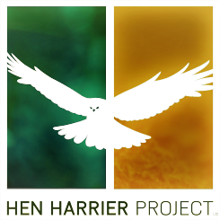

Local Grants for Hen Harrier SPAs
The Hen Harrier Project is launching a Local Actions Grants fund in your area. The budget for 2021 is €50,000. This initiative is available to farmers either individually or in groups, community groups, small local businesses, schools and sports or social clubs serving the community in breeding Hen Harrier SPAs. Grant aid is intended to address issues that could not be accommodated under the Habitat or Supporting Actions payments in the Hen Harrier Programme. The closing date for applications for the Spring 2021 round of Local Actions Grants is 5pm, March 12th, 2021.
Applications must be under one or more of the following themes.
- Enhancing Biodiversity
- Agricultural Sustainability
- Education and Training
- Support for local food or craft producers

Terms and Conditions:
- Applications must be in writing using the Hen Harrier Programme Local Grants Application Form.
- Applications for funding of up to €5,000 will be considered. The exact funding for each approved project will be agreed between the Hen Harrier Project Team and the applicants.
- Applicants must have a strong link to one or more of the breeding Hen Harrier SPAs. They must be able to demonstrate how the aid sought would be used to support innovation in agriculture and/ or biodiversity enhancement in these areas.
- All projects seeking funding must be delivered within a defined timeframe, typically 12 months.
- Applications will be subject to a screening for Appropriate Assessment procedure. The Hen Harrier Project Team will carry this out.
- Funding cannot be used to leverage funding from other public sources.
- The selection of successful applicants will be made by the Hen Harrier Project Team.
- Successful applicants must be able to sign a contract with the Hen Harrier Project. Clubs or groups must nominate an individual to take responsibility for the delivery of the successful project.
- Successful applicants must acknowledge funding from the Hen Harrier Project and clearly display the Hen Harrier Project logo on any promotional material.
- All payments will be by electronic funds transfer to an agreed bank account. The scheduling of payments will be agreed with the applicants.
Notes:
- Enhancing biodiversity: This could include habitat enhancement projects, nest protection measures, projects to support specific plant or animal species or local projects to reduce wildfire risk. This could include support for schools, sports clubs, nursing homes or others to increase the ecological value of their property or public spaces.
- Agricultural Sustainability: This could include management of feral animals or invasive species and the development of innovative farm level approaches to developing sustainable agriculture in the breeding Hen Harrier SPAs.
- Education and Training: Possible projects could include supporting farmer visits to learn from the experiences of others at home or abroad. It could also include projects designed to help local stakeholders access specialist training linked to agricultural sustainability or biodiversity support such as wildfire management.
- Local Food or Craft producers: Projects to develop local food or craft producers to develop or promote their product may be eligible for support. Successful applications under this heading must demonstrate provenance to one of the breeding Hen Harrier SPAs.

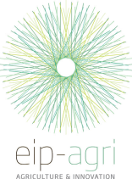
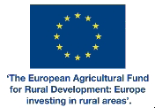
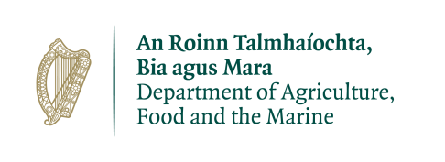
PLEASE FILL IN THE APPLICATION FORM OVER LEAF.
PLEASE SUBMIT FORMS ELECTRONICALLY TO:

admin@henharrierproject.ie

OR

VIA POST TO:
Hen Harrier Project
Local Actions Grants Fund
Unit 2, Oran Point
Oranmore,
Co. Galway,
H91 R6XH
 |  |  | Hen Harrier Programme
 |  |  | Local Grants
NAME OF APPLICANT(S)
Contact Person for
for group applications
ADDRESS
TELEPHONE NUMBER
E-MAIL ADDRESS
THEME |  | ENHANCING BIODIVERSITY
 |  | AGRICULTURAL SUSTAINABILITY
 |  | EDUCATION OR TRAINING
 |  | LOCAL PRODUCERS
 |  | COMMUNITY
 |  | Select one or more relevant themes
OBJECTIVE
HOW WILL THE
PROJECT BENEFIT
SUSTAINABLE AGRICULTURE,
BIODIVERSITY OR THE LOCAL COMMUNITY
DESCRIPTION OF HOW
THE PROJECT WILL BE
DELIVERED,
WHERE WILL THE
PROJECT BE DELIVERED
WHO WILL BE RESPONSIBLE
FOR THE DELIVERY OF THE
PROJECT
HOW WILL THE PROJECT
BE DEVELOPED, WHEN WILL
IT COMMENCE, KEY
MILESTONES,
WHEN WILL IT BE
COMPLETED
FUNDING SOUGHT |  | €
OTHER COMMENTS
Where appropriate please
attach other supporting
documentation
PLEASE SUBMIT FORMS ELECTRONICALLY TO:

admin@henharrierproject.ie

OR

VIA POST TO:
Hen Harrier Project
Local Actions Grants Fund
Unit 2, Oran Point
Oranmore,
Co. Galway,
H91 R6XH

